**HOME APPLIANCES CONTROLLED USING BY ANDROID APP**

**By**

**ABHISHEK PANDEY (1901660300003)**

**ADEEBA RAZI (1901660300005)**

**POOJA MAURYA (1901660300037)**

**RADHIKA DEVI (1901660300043)**

**Department of Electronics Engineering**

**Dr Ambedkar Institute of Technology for** **Handicapped, Kanpur – 208024**

**May,2023**

**HOME APPLIANCES CONTROLLED USING BY ANDROID APP**

**By**

ABHISHEK PANDEY (1901660300003)

ADEEBA RAZI (1901660300005)

POOJA MAURYA (1901660300037)

RADHIKA DEVI (1901660300043)

Submitted to the Department of Electronics Engineering

in partial fulfilment of the requirements

for the degree of

**BACHELOR OF TECHNOLOGY**

In

**Electronics Engineering**



**DR. AMBEDKAR INSTITUTE OF TECHNOLOGY FOR HANDICAPPED,**  **KANPUR**

**- 208024**

**Dr A.P.J. ABDUL KALAM TECHNICAL UNIVERSITY, LUCKNOW**

**CERTIFICATE**

*This is to certify that Project Report entitled “****Home Appliances controlled using by android app****” which is submitted by* ***Abhishek pandey, Adeeba Razi, Pooja Maurya, Radhika Devi*** *in partial fulfilment of the requirement for the award of Degree B.Tech. in Department of Electronics Engineering of DR. A.P.J. Abdul Kalam Technical University is a record of the candidates own work carried out by him under our supervision. The matter embodied in this thesis is original and has not been submitted for the award of any other degree.*

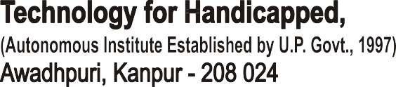

MR. B. R. SINGH MRS.SHWETA TRIPATHI

(Project Guide) (In-charge)

(Assistant Professor ) EL Department

EL Department

**Date:**

**DECLARATION**

*We hereby declare that this submission is our own work and that, to the best of my knowledge and belief, it contains no material previously published or written by another person nor material which to a substantial extent has been accepted for the award of any other degree or diploma of the university or other institute of higher learning, except where due acknowledgment has been made in the text.*

ABHISHEK PANDEY ADEEBA RAZI

(1901660300003) (1901660300005)

POOJA MAURYA RADHIKA DEVI

(1901660300037) (1901660300043)

Date of Submission:

# 

# ACKNOWLEDGEMENT

*It gives us a great sense of pleasure to present the Report of the B.Tech. Project undertaken during B.Tech. Final Year. Our deep sense of gratitude to our project guide* ***Mr. B.R. Singh (Assistant Professor), Department of Electronics Engineering, Dr. AITH, Kanpur*** *for her constant support and guidance throughout the course of our work. Her sincerity, thoroughness and perseverance have been a constant source of inspiration for us. It is only her constant efforts that our endeavors have seen light of the day. We also take the opportunity to acknowledge the contribution of* ***Mrs. Shweta Tripathi, (Head), Department of Electronics Engineering, Dr. AITH, Kanpur*** *for her full support and assistance during the development of the project. We also do not like to miss the opportunity to acknowledge the contribution of all faculty members of the department for their kind assistance and cooperation during the development of our project. Last but not the least, we acknowledge our friends for their contribution in the completion of the project.*

|  |  |  |  |  |  |  |
| --- | --- | --- | --- | --- | --- | --- |
|  |  |  |  |  |  |  |
| ABHISHEK PANDEY |  |  |  |  |  | ADEEBA RAZI |
| (1901660300003) |  |  |  |  |  | (1901660300005) |
| POOJA MAURYA | RADHIKA DEVI | | | | | |
| (1901660300037) | (1901660300043) | | | | | |

**Date:**

# ABSTRACT

The Home Automation System is implemented for decades but due to the costing and budgeting of the project, it remains a nice product for high-end consumers. The Intelligent Home Automation System, security is one of the major factors that does not implement in the Home Automation System. The hectic daily life routine sometimes makes them forget to switch off their devices at home. The clumsy attitude plus the packed daily routine life that sometimes makes us such in hurry situation that sometimes makes us forgot to switch off the lamps. It will cause the electricity bill to rise sharply. Besides, it is one of the electricity wastages that will lead the earth became an unhealthy one. The strength of this project is to control the devices such as lamps and door at home using a smartphone. The system is related to home appliances using ESP12. Home appliances can help the user to control the devices at home and develop a good condition of house area that will prevent any loss and damage to the property of any organization. The hardware that is being used in this project is a Relay, Servomotor, Bulb Holder, Bulb, Gas Sensor, Laser, LCD, Fingerprint Sensor, ESP32. Most of the project that is related to home automation or known as home appliances most of it using the Blynk Apps. This project is using a smartphone to give command compare to another project that is using tablet, laptop and others which is much more convenient to users.

# 

# List of Figures

Figure 3.1 ESP12…………………………………………………………………….8

Figure 3.2 Pin and their Different Functions on ESP12……………………………...9

Figure 3.3 Pin Description of ESP12(Top View) ………………………………...…9

Figure 3.4 Working Principle of the Home Automation Application………………..13

Figure 3.5 2-channel-5v-relay-module ………………………………………………13

Figure 3.6 Circuit Diagram of the system……………………………………………14

Figure 3.7 Simple Block Diagram of proposed system……………………………...19

Figure 3.8 Basic Block Diagram of Home Automation ……………………………….20

Figure 3.9 Creating an account and generating a unique ID in the Home automation server….…………………………………………………………………………….....21

Figure4.0 Setup to control ESP12 MCU from Home Automation Application……………………………………………………………………..…..….21

Figure 4.1 Flow Chart of Prototype Function…………………………………….…...22

**Table of Contents**

CERTIFICATE ………………………………………………………………………….iii

DECLARATION …………………………………………………………………………………..iv

ACKNOWLEDGEMENT v

ABSTRACT vi

List of Figure vii

Chapter 1: Introduction…………………………………………………………………….….1- 3

1.1 Introduction to Home Automation .......................................................................... 1

1.2 Background .............................................................................................................. 1

1.3 Issues with Home Appliances Management ............................................................. 3

1.4 Chapter Summary ..................................................................................................... 3

Chapter 2: Literature Review…………………………………………………………............... 4-6

Chapter 3: Theory……………………………………………………………………................. 7-14

3.1 Microcontroller Selection for Home Appliances……….…………………………7

3.1.1 Comparing the Microcontroller..……………………………….………...7

3.2 ESP12…………………………….………………….………………...……….… 7

3.3 PIN CONFIGURATION OF ESP12 BOARD…………………………………...8

3.4 PIN DESCRIPTION……………………………………….….…………………..9

3.5 Home Automation App……………………………………………………………12

3.6 BLYNK App…………………………………………………………………………12

3.7 Relay……………………………………………………………………….…….13

3.8 Circuit Diagram………………………………………………………………….14

3.9 Advantages……..………………………………………………………………..15-16

3.9.1 Wireless Transmission of Data…………...…………………………15

3.9.2 Extensive Availability and Accessibility….....………………………15

3.9.3 Convenience from the ease of use.……………...……………...........15

3.9.4 Energy Efficiency……….…………………………………………..16

3.10 Disadvantages ………………….. ………………………………………….16 -18

3.10.1 Limited Operational range…………………………………………16

3.10.2 Can be energy efficient….…………………………………………16

3.9.3 Slower Transmission than others.………………………….............17

3.10.4 Possible interface security vulnerability.…………………………17

3.10.5 Compatibility issue….……………………………………… …...17

3.11 Application………………..………………………………………………..18

Chapter 4: Logic and Operation……………………………………………………………19-22

4.1 Block Diagram of System…………………………………………………..19

4.2 Overview of Project…………………………………………………………20

4.3 Flow Chart………………………………………………………………….22

Chapter 5: Conclusion and Future Scope………………………………………………….23

5.1 Result……………………………………………………………………….23

5.2 Further Enhancement and Future Scope……………………………………..23

5.3 Conclusion…………………………………………………………………...23

References…….………………………………………………………………………...24

**CHAPTER 1**

## INTRODUCTION

**1.1 Introduction to Home Automation**

The aim of the proposed system is to develop a cost-effective solution that will provide controlling of home appliances remotely and enable home security against intrusion in the absence of homeowner. The home appliances control system with an affordable cost was thought to be built that should be providing remote access to the appliances and allowing home security. Though devices connected as home and office appliances consume electrical power. These devices should be controlled as well as turn on/off if required. Most of the times it was done manually. Now it is a necessity to control devices more effectively and efficiently at anytime from anywhere. In this system, we are going to develop a remote control-based home/office appliance. Remote control for home appliances is an absolute necessity in our fast-paced life. As a result, much important has been given to this aspect and a range of remote controls are prevalent today. One of the most common is that which makes use of IR radiations at particular frequencies. Our product is a Remote Operated Home Appliance or remote controlled home appliance. The circuit is connected to any of the home appliances (lamp, fan, radio, etc) to make the appliance turn on/off from a TV, VCD, VCR, Air Conditioner or DVD remote control. The circuit can be activated from up to 10 meters. It is very easy to build and can be assembled on a general-purpose PCB. For this purpose we make a circuit that consist of a IR module, CD4017 IC, LEDs to indicate the reception of the IR radiations, otherwise indicating the ON/OFF state, relay and other components .

### 1.2 Background

• An electronic system is an electronic circuit with components de-signed to accomplish either simple or complex functions for in-stance in home automation architecture. Typical examples of such sub-systems used in home automation include items such as a telecommunications system; computer system and some automation systems. Such integrated systems are the fundamental components of the automatic control encountered in other various control systems; their design intends suppressing or minimizing the involvement of human work and thus saving also the energy consumption, since such a control system uses the technique of self-moving processes to do the work. In fact, home automation is one of the first projects one thinks about when wanting to make the life easier, comfortable, and secure; etc. But, with a hope to financially spend little on the costs bill, therefore, to save the energy consumption at home because it involves as better way [3] [4] [5] the control and manages the home equipment such as lighting, home appliances use, heating/Air-Cond; etc. With the popularity and widespread around the world of the smart-homes, there is high chance for a continuous need for automatic control of home and its appliances. Hence, a new terminology in daily people communications is known as demotics, which is the “technique of technological applications in the control of house appliances by electronically controlled systems” [6] [7]. In fact, switches are set “ON” at least dozens of times a day, and most of the times they are forgotten to be turned “OFF”’; and with such happening the lights for instance will consume more energy and this will increase also the electric bill budget. Therefore, with demotics, home’s user can control the equipment connected to a dedicated system for that purpose. Furthermore, there are very few worldwide accepted industry standards for demotics’ based devices /systems development. There-fore, the smart home space/field is still heavily fragmented while there are many competing vendors. Bluetooth is one of the popular communication protocols for the products that are used in the home automation [5] [6] [10]. Based for examples various journal articles and technical reports here are some of the most obvious reasons for Bluetooth based products popularity. Fist, this system has avoided the use of new cables for connections. Secondly, the manufacturers often prevent independent implementations by withholding documentation. Third, wired or wireless technologies can support the communications between the systems to deliver required operation services. Fourth, currently an upgraded Bluetooth that is designed to reduce the power consumption and the comparison of the short-range wireless technology is permitted to evaluate if that Bluetooth version is a good alternative. In fact, the upgraded version offers low power consumption, low cost and its general availability in tablets and smartphones; and also it can be easily used to control and monitor all the systems. In this article, the discussed piece of study on controlling home appliances such as lamps and fans with is mainly to demonstrate how to design a simple, low-cost system like others for widely use in future. In more details, demotics, enable home’s user to easily control the equipment connected to a smartly designed system. And, this system consists of a smartphone, a tablet or a personal computer, which enable connecting to the home equipment’s switches through Bluetooth or Internet.

### 1.3 ISSUES WITH HOME APPLIANCES MANAGEMENT

One of life living style problems today is about the waste of energy resources in home. Energy is limited for use in great amount in what to make lives easier, comfortable and, productive. It is important to use the energy resources wisely and always try to save the electrical power; for, the recourse is very important for us later.

“The earth provides enough to satisfy every man’s needs, but not every man is greed” [10]. Otherwise, conserving electricity in homes consumption will create the accumulated savings in energy bills at the end of the year. And, conserving electricity is important beyond the impact on financial budget since it can also cause the depletion of natural energy used to generate electricity. Human attitudes is one of the factors that contribute to the higher electric power consumption due to the habit of wasting electricity and because of the lack of awareness towards energy saving. Most of the people nowadays tend to forget to switch OFF the lamp and fan when leaving their house because it has already become a part of their behaviour. Based on observations, there are many cases where the consumers forgot to switched OFF the lamps when they come out from the washroom especially children and teenagers [4]. The use of electricity continuously in the washroom without any occupant could lead to the energy wastage. However, the variation in these observations shows that home occupant’s switching behaviour is complicated; because depending on other things like the individual personality, on the available daylight, time of the day, type of electric lighting, type of switch and location to users’ sight/reach [6] [7] [10].

#### 1.4 Chapter Summary

 An experiment involving two stages work is discussed under this section regarding the points to achieve during the development of this application. The prototype has been tested to ensure the circuit well-functioning and its connections correctness. The circuit containing Bluetooth module and PIR sensor was prepared and inter-connected using Arduino, and then tested in simulations method. An example of this design work can apply a simple algorithm like the following: a) Project definition and model choice >> Material selection >> Product requirements preparation/gathering >> Actual design work. b) A flowchart associated with (a)’s steps (e.g. Figure5). Figure-5. Project design simplified flowchart. The overall steeps for the project realization stages can be summarized into six sequences (Figure-5), namely: planning/ideas brain-storming, literature review; project design, prototype implementation; modelled solutions testing and validation. Basically, the work under each goes this way: The preparation includes planning what project to be developed. The reviews to finding more details about the project component, function and etc., The design is to produce the project layout and related work to its appearance; The prototype is done using the material selected based on the characteristics that are correlated to each other; The assembled prototype is implemented according to the design model (e.g. plan/diagram and dimensioning. fit); Finally, the prototype testing upon execution allows seeing what can be the first performance result. This is repeated as many as possible to ensure all potential errors are resolved. Lastly, when the resolved problems are analysed, the details can be written to make sure that the project functions well.

**CHAPTER 2**

### LITERATURE REVIEW

**“Smart Energy Efficient Home Automation System using WiFi”, by Satyendra K. Vishwakarma, Prashant Upadhyaya, Babita Kumari, Arun Kumar Mishra.**

This paper presents a step-by-step procedure of a smart home automation controller. It uses Bluetooth to convert home appliances to smart and intelligent devices, with the help of design control. An energy efficient system is designed that accesses the smart home remotely using Bluetooth connectivity. The proposed system mainly requires, Node MCU as the microcontroller unit, IFTTT to interpret voice commands, Adafruit a library that supports MQTT acts as an MQTT broker and ESP 12 to code the microcontroller. This multimodal system uses Google Assistant along with a web-based application to control the smart home. The smart home is implemented with main controller unit that is connected with the 24-hour available Wi-Fi network. To ensure, that the Wi-Fi connection do not turn off, the main controller is programmed to establish automatic connection with the available network and connected to the auto power backup.

**“Wifi Based Smart Security and Home Automation”, by Shradha Somani, Parikshit Solunke, Shaunak Oke, Parth Medhi, Prof. P. P. Laturkar.**

This paper focuses on a system that provides features of Home Automation relying on Bluetooth to operate easily, in addition to that it includes a camera module and provides home security. The android application basically converts Smartphone into a remote for all home appliances. Security is achieved with motion sensors if movement is sensed at the entrance of the house; a notification is sent that contains a photo of house entrance in real time. This notification will be received by the owner of the house via internet such that app can trigger a notification. So, owner can raise an alarm in case of any intrusion or he/she can toggle the appliances like opening the door if the person is a guest. The system uses Raspberry Pi, a small sized computer which acts as server for the system. The smart home consists two modules. Home automation that consists; fan light and door controller, and security module that consists; smoke sensor motion sensor and camera module.

**“A Dynamic Distributed Energy Management Algorithm of Home Sensor Network for Home Automation System”, by Tui-Yi Yang, Chu-Sing Yang, TienWen Sung.**

This paper proposes an optimization of home power consumption based on PLC (Power Line Communication) for an easy to access home energy consumption. This also proposes a Zigbee and PLC based renewable energy gateway to monitor the energy generation of renewable energies. ACS and DDEM algorithm are proposed for the design of an intelligent distribution of power management system to make sure ongoing power supply of home networks. To provide efficient power management the power supply models of home sensor network are classified groups viz. main supply only, main supply and backup battery, rechargeable battery power and non-rechargeable battery power. Devices with particular features are assigned to these groups. It targets to establish real time processing scheme to address variable sensor network topologies.

**“Enhance Smart Home Automation System based on Internet of Things”, by Tushar Churasia and Prashant Kumar Jain.**

This paper proposes a system that develops a model to reduce the computation overhead in existing smart home solutions that uses various encryption technologies like AES, ECHD, hybrid, etc. these solutions use intermediate gateway for connecting various sensor devices. The proposed model provides a method for automation with sensor-based learning. The system uses temperature sensor for development but other sensors can also be used as per requirement. These smart home devices with sensors can configure themselves autonomously and can operate without human intervention. This work minimizes encryption decryption and focuses on authentication and automation of smart home devices with learning. The system bypasses local gateway mentioned in existing system to provide better security for smart home devices and sensor data and save computation overhead. The real time broker cloud is directly connected with smart home and manages all incoming and outgoing request between users and devices. The main purpose to use real time broker cloud is save time of cryptographic operations.

**“Visual Machine Intelligence for Home Automation”, by Suraj, Ish Kool, Dharmendra Kumar, Shovan Barman.**

The paper presents a vision-based machine intelligence system to sense on/off state of common home appliance. The proposed method of sensing the state of appliances results on a novel home automation system. The accessibility of the suite of devices in the home over a remote network is facilitated by the IP Addressing methods in the IOT. This project uses two boards viz. Raspberry Pi and Intel Galileo Gen 2. The communication between the User devices, Raspberry Pi and the Intel Galileo boards happens over a wireless network. The UDP protocol is deployed to facilitate the wireless communication of the nodes present in the home automation network. A Pi Cam and a USB Logitech camera attached to the rotating shaft of two different servo motor capture snapshots that are passed as inputs to the Machine Learning based models trained using C++ to detect the state of the operation of the appliances. The proposed method uses visual modality to automate the appliances, as privacy concerns may emerge while using the images from some specific places, as a counter to this issue, an SPDT switch is added to the Raspberry Pi which when turned off ensures that even if the images are taken from the webcams, they are just passed as inputs to the machine learning models and are not displayed on the website when the users access the website on the server address obtained from Raspberry Pi.

**“A Low-Cost Home Automation System Using Wi-Fi based Wireless Sensor Network Incorporating internet of Things”, by Vikram.N, Harish.K. S, Nihaal.M. S, Raksha Umesh, Shetty Aashik Ashok Kumar.**

This paper illustrates a methodology to provide a low-cost Home Automation System (HAS) using Wireless Fidelity (Wi-Fi). This crystallizes the concept of internetworking of smart devices. A WiFi based Wireless Sensor Network (WSN) is designed for the purpose of monitoring and controlling environmental, safety and electrical parameters of a smart interconnected home. The different sections of the HAS are; temperature and humidity sensor, gas leakage warning system, fire alarm system, burglar alarm system, rain sensing, switching and regulation of load & voltage and current sensing. The primary requirement of HAS to monitor and control of devices is accomplished using a Smartphone application. The application is developed using Android Studio based on JAVA platform and User Interface of those are exemplified. The primary focus of the paper is to develop a solution cost effective flexible in control of devices and implementing a wide range of sensors to to capture various parameters.

**Review of Foreign Studies:**

In their paper, Tan, Lee and Soh (2002) proposed the development of an Internet-based system to allow monitoring of important process variables from a distributed control system (DCS). This paper proposes hardware and software design considerations which enable the user to access the process variables on the DCS, remotely and effectively Potamitis, Georgila, Fakotakis, and Kokkinakis, G. (2003) suggested the use of speech to interact remotely with the home appliances to perform a particular action on behalf of the user. The approach is inclined for people with disability to perform real-life operations at home by directing appliances through speech. Voice separation strategy is selected to take appropriate decision by speech recognition In the year 2006 , S. M. Anamul Haque,S. M. Kamruzzaman and Md. Ashraful Islam proposed a system entitled “A System for Smart-Home Control of Appliances Based on Time and Speech Interaction” that controls the home appliances using the personal computer. This system is developed by using the Visual Basic 6.0 as programming language and Microsoft voice engine tools for speech recognition purpose. Appliances can be either controlled by timer or by voice command.

**CHAPTER 3**

## THEORY

### 3.1 Microcontroller Selection for Home Appliances

In this project, we are using the ESP12 rather than the Arduino, Microcontroller, Wi-fi module, GSM, and others. 3.6.1 Comparing the Microcontrollers Comparing the potential microcontrollers that can be used for making the project.

#### 3.1.1 Comparison of NODEMCU and ARDUINO UN

|  |  |
| --- | --- |
| **NODEMCU** | **ARDUINO UNO** |
| 128 kb RAM | 2 kb RAM |
| 4 Mb of ROM (flash) can store more code compares to UNO. | 32 Mb |
| Comes with a micro-USB port | Comes with USB type B connector |
| Small in size | Bigger than NODEMCU |

**3.2 ESP12**

ESP-12F WiFi module is developed by Ai-thinker Team. core processor ESP8266 in smaller sizes of the module encapsulates Tensilica L106 integrates industry-leading ultralow power 32-bit MCU micro, with the 16-bit short mode, Clock speed support 80 MHz, 160 MHz, supports the RTOS, integrated Wi-Fi MAC/BB/RF/PA/LNA, on-board antenna. The module supports standard IEEE802.11 b/g/n agreement, a complete TCP/IP protocol stack. Users can use the add modules to an existing device networking, or build a separate network controller. ESP8266 is high integration wireless SOCs, designed for space and power-constrained mobile platform designers. It provides unsurpassed ability to embed WiFi capabilities within other systems or to function as a standalone application, with the lowest cost, and minimal space requirement.

ESP8266EX offers a complete and self-contained Wi-Fi networking solution; it can be used to host the application or to offload Wi-Fi networking functions from another application processor. When ESP8266EX hosts the application, it boots up directly from an external flash. It has an integrated cache to improve the performance of the system in such applications. Alternately, serving as a Wi-Fi adapter, wireless internet access can be added to any microcontroller based design with simple connectivity (SPI/SDIO or I2C/UART interface). ESP8266EX is among the most integrated WiFi chip in the industry; it integrates the antenna switches, RF balun, power amplifier, low noise receive amplifier, filters, power management modules, it requires minimal external circuitry, and the entire solution, including front-end module, is designed to occupy minimal PCB area. ESP8266EX also integrates an enhanced version of Tensilica’s L106 Diamond series 32-bit processor, with on-chip SRAM, besides the Wi-Fi functionalities. ESP8266EX is often integrated with external sensors and other application-specific devices through its GPIOs; codes for such applications are provided examples in the SDK.

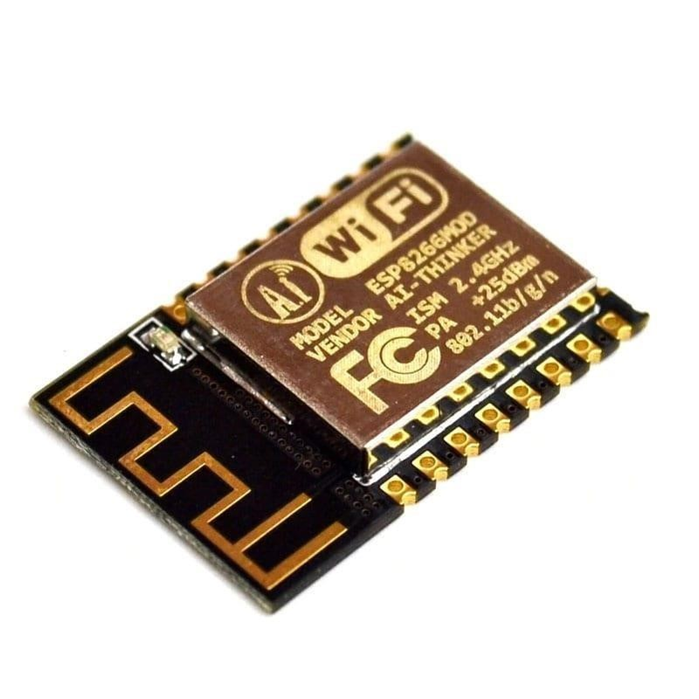

Fig 3.1 ESP12

)

**3.3 Pin Configuration of ESP12F Board**

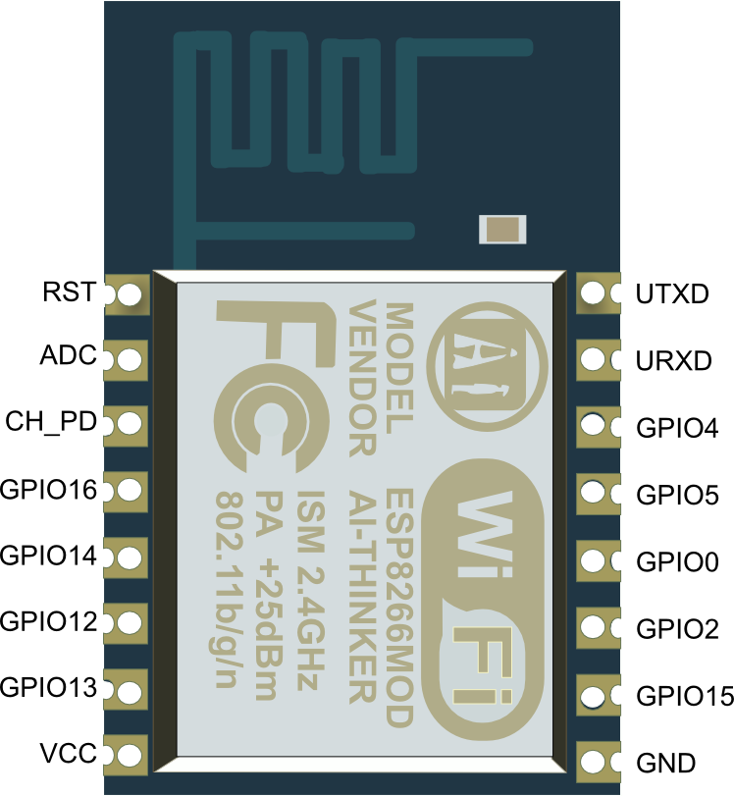

Fig 3.3 Pin Description of ESP12 (top view)

**3.4 Pin description**

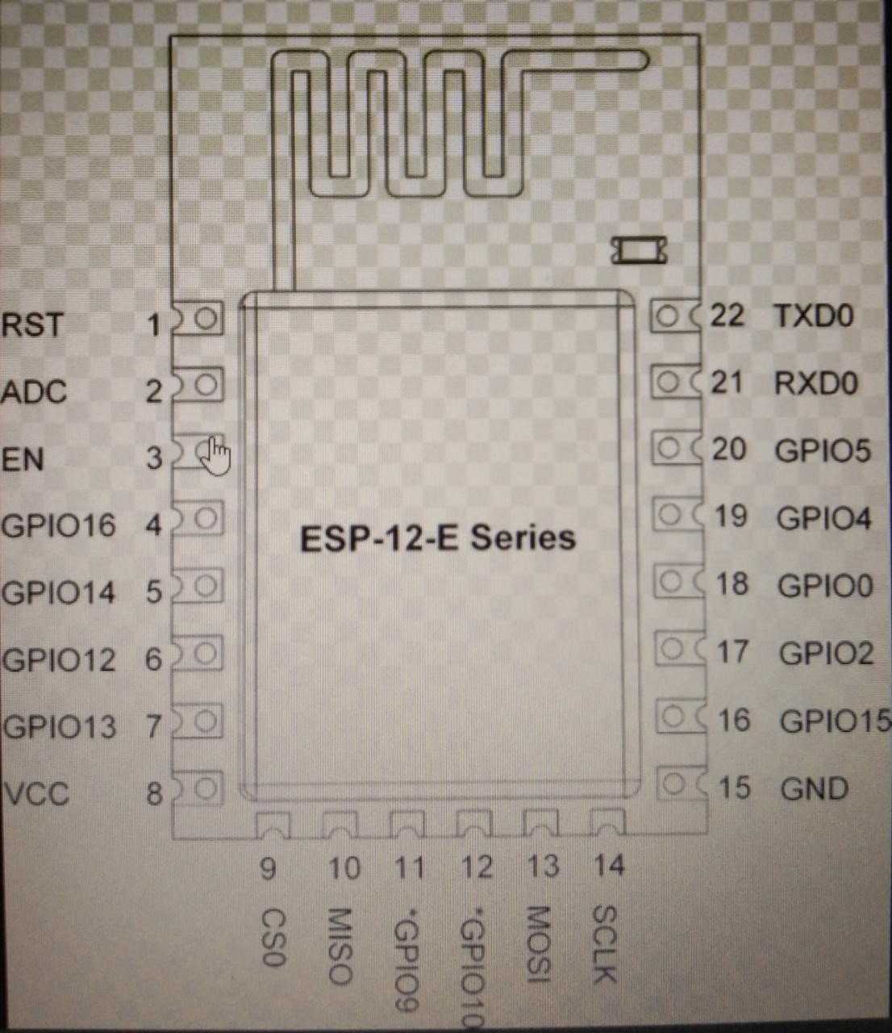

### 

### 3.5 Home Automation App

The home automation application was designed for the primary purpose of the

Internet of Things. Home automation app is a platform with Android apps to control

Arduino, Raspberry Pi, and the likes over the Internet. It’s a digital dashboard where a graphic interface for a prototype can be built by simply dragging and dropping widgets. It can control hardware remotely, it can display sensor data, can store and visualize data, and possessed a lot more functionality. There are three major components in the platform. Home Automation Application allows to you create amazing interfaces for your projects using various widgets we provide. The Home Automation server is responsible for all the communications between the smartphone and the hardware. You can use our Home automation Cloud or run your private Home Automation server locally. It’s open-source, could easily handle thousands of devices, and can even be launched on a Raspberry Pi. Home Automation app Libraries for all the popular hardware platforms – enable communication with the server and process all the incoming and outgoing commands. Every time a radio button is accessed in the Blynk application, the message travels to the Home Automation Cloud, where it finds the specific hardware by the uniquely generated authentication token. It works in the same way for the opposite direction.

**3.6 BLYNK App**

The Blynk application was designed for the primary purpose of Internet of Things. Blynk is a platform with IOS and Android apps to control Arduino, Raspberry Pi and the likes over the Internet. It’s a digital dashboard where graphic interface for a prototype can be built by simply dragging and dropping widgets. It can control hardware remotely, it can display sensor data, can store and visualize data and possessed a lot more functionality. There are three major components in the platform: Blynk Application: allows to you create amazing interfaces for your projects using various widgets we provide. Blynk Server: responsible for all the communications between the smartphone and hardware. You can use our Blynk Cloud or run your private Blynk server locally. It’s an opensource, could easily handle thousands of devices and can even be launched on a Raspberry Pi. Blynk Libraries: for all the popular hardware platforms – enable communication with the server and process all the incoming and outgoing commands. Every time a radio button is accessed in the Blynk application, the message travels to the Blynk Cloud, where it finds the specific hardware by the unique generated authentication token. It works in the same way for the opposite direction.

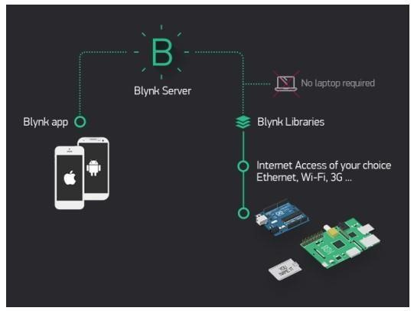

Fig 3.4 Working of Home Automation App

### 3.7 RELAY

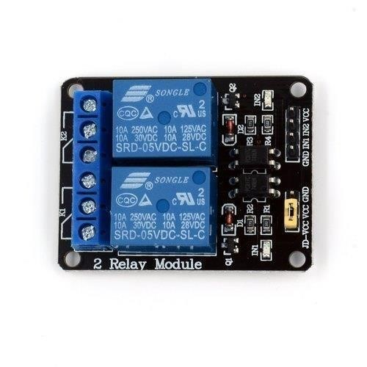

Fig 3.5 2-channel-5v-relay-module

The 2 Channel Relay Module is a convenient board that can be used to control high voltage, high current loads such as motors, solenoid valves, lamps, and AC loads. It is designed to interface with microcontrollers such as Arduino, and PIC. The relay terminal (COM, NO, and NC) is being brought out with a screw terminal. It also comes with a LED to indicate the status of the relay. Can also be used in driving high-power motors. 4-channel relay output modules, relay output contacts 250A 10A. Input IN1, IN2, the signal line LOW effective.

VCC, GND power input, can relay a separate power supply relay power input of JD-VCC.

**3.8 Circuit Diagram**

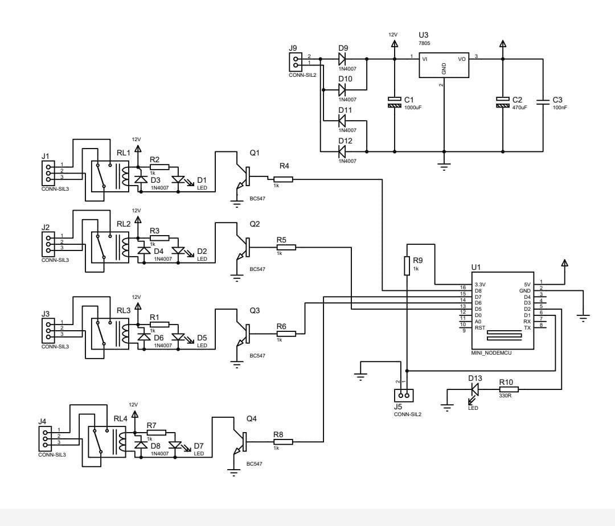

Fig 3.6 circuit diagram of system

**3.9 Advantages**

|  |  |
| --- | --- |
| **3.9.1 Wireless Transmission of Data**  One of the primary advantages of Bluetooth is that it allows devices to transmit data wirelessly. This advantage translates to more specific benefits including wirelessly connecting or “pairing” devices to create a wireless personal area network or WPAN, wireless Internet connectivity, and wireless synchronization, as well as conveniently sending and/or receiving files without the trouble of carrying and using cables or other hardware interfacing technology such as the USB standard or [Thunderbolt technology.](https://www.profolus.com/topics/advantages-and-disadvantages-of-thunderbolt-interface/)  Note that other applications of wireless connectivity via Bluetooth include remote control between a device and another compatible device or appliance, real-time location systems for locating and identifying objects within a determined distance, personal security for preventing theft or loss of devices such as smartphones, and in health monitoring and recording using Bluetooth-enabled medical devices. |  |
| **3.9.2. Extensive Availability and Accessibility** | |
| The numerous applications of Bluetooth demonstrate its extensive and almost universal availability. Most laptops and other mobile devices such as smartphones and tablet computers come with a built-in Bluetooth hardware. For personal computers that do not have the required hardware component, purchasing and using a Bluetooth adapter will enable them to communicate with Bluetooth-enabled devices.  Complementary devices have been developed and marketed because Bluetooth has seemingly become a standard feature of modern computers, specifically laptops and mobile devices. These devices included wireless speakers and headphones, smart devices such as smartwatches and other wearable technologies for monitoring activities, and Bluetooth enabled smart home appliances and office equipment, among others. |  |
| **3.9.3. Convenience from Ease of Use** | |

Pairing devices with built-in Bluetooth radio is considerably easy. There is no need to install additional software or driver to establish communication between Bluetooth-enabled devices. There is also no rigorous setup process for two devices to communicate.

The technology simplifies the entire pairing process by making enabled devices readily discoverable to one another as long as that their Bluetooth radios are turned on, and they are within the coverage radius. In addition, the technology also includes a protocol for identifying services using the Service Discovery Protocol and Universal Unique Identifier to list down specific services or features of a particular device. These protocols allow another device to readily determine and display the name and class of a device it intends to pair with, as well as its services or features and technical information.

##### 3.9.4. Energy Efficiency

Bluetooth technology is relatively energy efficient, thus promoting further the benefits and convenience that come with wireless data transmission. This is particularly true for the Bluetooth Low Energy or BLE standard. The ultra-low power requirement of BLE makes it ideal for small devices, including wearable technologies, in which minimal battery life requirement and small form factor are critical design and engineering considerations.

The newest iteration to the technology called Bluetooth 4.0 also promises better power efficiency than Bluetooth 3.0. This new specification features the same BLE technology and classic Bluetooth standard found in an older Bluetooth specification, thus allowing the dual mode to take advantage of energy efficiency and faster data transfer rates.

### 3.10 Disadvantages

#### 3.10.1. Limited Operational Range

A notable disadvantage or limitation of Bluetooth is its limited range that is dependent on the specific class of radio it uses. Enabled devices can only establish and maintain wireless communication as long as they are within the range limit. To be specific, Class 1 radios have a range of 20 to 30 meters for commercial use and up to 100 meters for industrial use cases, while those with Class 2 radios have a more limited range of up to 10 meters. Class 3 radios operation within the range of fewer than 10 meters.

#### 3.10.2 Can Be Energy Inefficient

The fact remains that Bluetooth requires minimal energy requirement, especially in the case of BLE. However, in real-world applications, the technology can significantly drain the battery life of a device, particularly if it remains turned on. Note that devices such as smartphones and tablet computers use their battery life for different software processes and to keep its numerous hardware components running. A Bluetooth radio increases the power requirement of a device.

In addition, it is worth mentioning that energy efficiency is dependent on the specific class of radio. Class 1 radios are more power intensive because they have a transmission range of up to 10 meters under 100 megawatts, thus making them suitable for personal computers. Class 2 radios transmit at 2.5 megawatts while Class 3 radios transmit at 1 megawatt. Take note that the longer the range, the greater the power requirement.

|  |
| --- |
| **3.10.3. Slower Transmission Than Other Interface**  Another disadvantage of Bluetooth is its slower data transmission rate when compared to other hardware interfacing technologies. To be more specific, Bluetooth 3.0 and Bluetooth 4.0 have a theoretical transmission rate of 24Mbps while [Wi-Fi Direct h](https://www.profolus.com/topics/advantages-and-disadvantages-of-wi-fi-direct/)as a transfer speed of up to 250Mbps. Wired hardware interfaces such as USB 3.0 has a transmission speed of up to 5Gbps while [Thunderbolt 3 supports a](https://www.profolus.com/topics/advantages-and-disadvantages-of-thunderbolt-interface/) transfer speed of up to 40Gbps.  The aforementioned disadvantage translates to more specific limitations. For example, Bluetooth would not be ideal for transferring large files such as an audio-video content or multiple image documents between devices, particularly for time-sensitive use cases. Coupled with its limited range, the technology is impractical for mid-range to long-range wireless transmission.    **3.10.4 Possible Security Vulnerabilities**  Bluetooth technology implements numerous security measures to prevent unauthorized access. Such measures include confidentiality, authentication and key derivation with custom algorithms. However, there have been numerous cases of security concerns documented by researchers and media organizations, including [the use of malware t](https://www.profolus.com/topics/different-types-of-malware/)o hack hardware controls and the BlueBorne exploits first reported in 2017. |
| Misuse or irresponsible use of Bluetooth-enabled device and other Bluetooth implements can also increase the security vulnerability of an individual or organizations. Such include readily allowing random pairings or keeping the radios turned on without using authorization keys. Note that the technology is susceptible to denial-of-service attacks, eavesdropping, man-in-the-middle attacks, message modification, and resource misappropriation. |

#### 3.10.5. Compatibility Issues

While the implementation of Bluetooth is based on a standard, compatibility and functionality issues are still common due to a combination of different factors such as the particular version, drivers, and profiles, among others. Take note that although Bluetooth

3.0 and 4.0 are backward compatible with older versions such as Bluetooth 1.0 and Bluetooth 2.0, there are specific instances of incompatibility.

For example, the low-energy technology of Bluetooth 4.0 is not compatible with other classic Bluetooth versions. This means that a device equipped with Bluetooth 4.0 that only has the low-energy technology component will not work with a device equipped with Bluetooth 2.0.

Adding to this is the fact that BLE is not compatible with classic Bluetooth.

## 3.11 Applications

* HC-05 Bluetooth Module is normally used for wireless data transmission among multiple microcontrollers.
* It can also be used to communicate between electronic devices like mobile, laptop, computers for data transmission.
* It also used in different information and data-logging applications.
* It's used in robotics for wireless control.
* It's used in autonomous projects for collecting data.

**Chapter 4**

## LOGIC AND OPERATION

### 4.1 BLOCK DIAGRAM OF THE SYSTEM

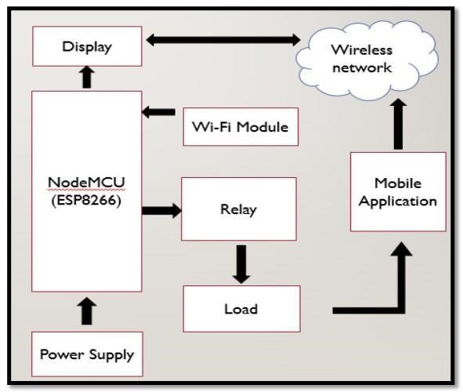

Fig 3.7 Block Diagram of system

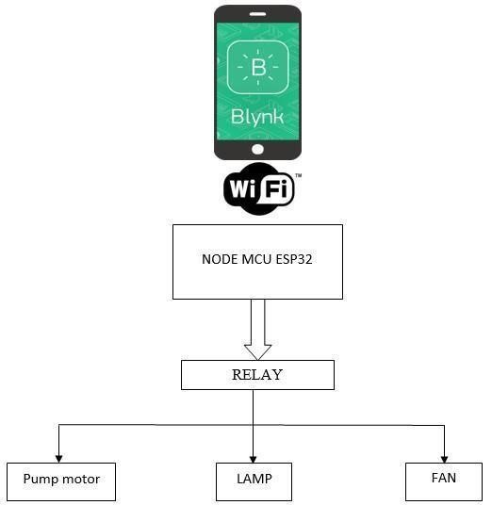

Fig 3.8 Basic Block Diagram of Home Automation

### 4.2 OVERVIEW OF THE PROJECT

The following describes the process of creating an account in the Home Automation application and generating a unique ID against a particular device. This ID acts as an identifier for the particular device on the Blynk server.

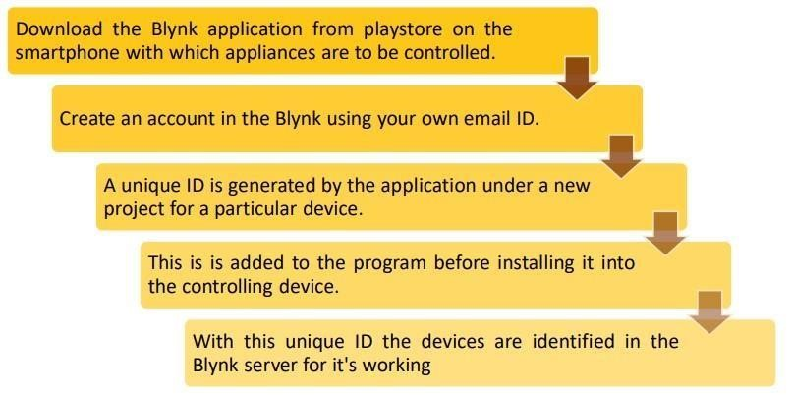

Fig.3.9 Creating an account and generating unique ID in Home Automation Server

Once the unique Id is generated the next step would be to include this key into the coding written in embedded C to establish communication between Node MCU and Blynk Server. The following describes this process.

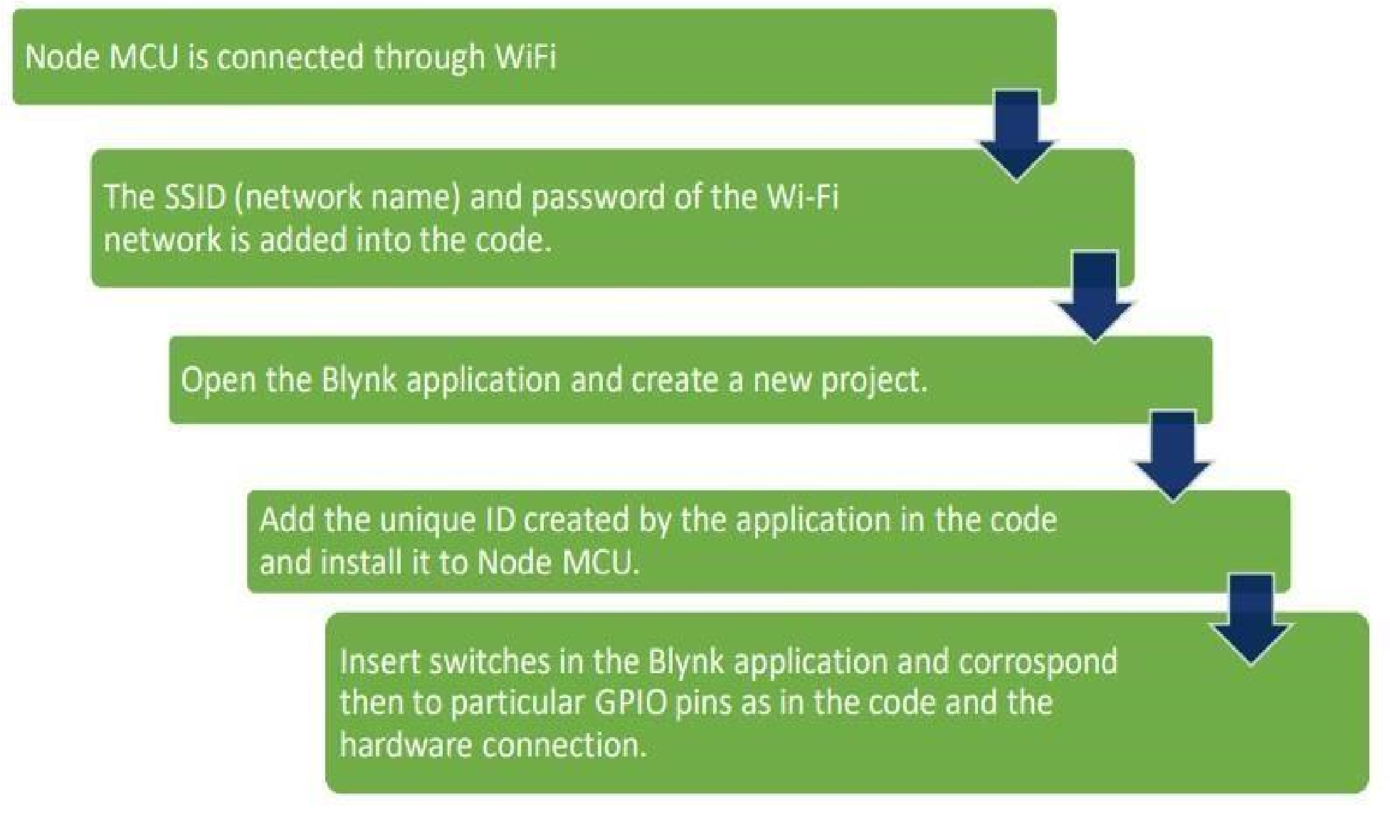

Fig 4.0 Setup to control ESP12 MCU from Home Automation application

#### 4.3 FLOW CHART

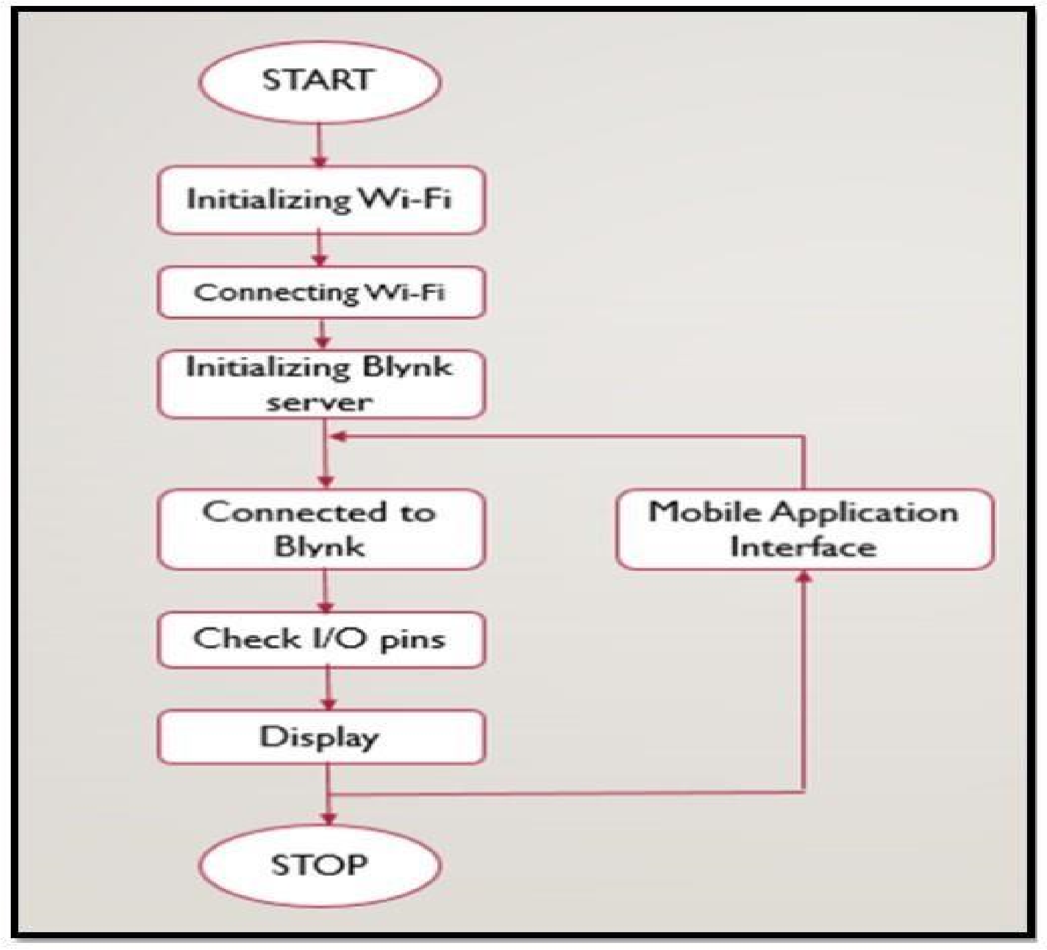

Fig.4.1 Flow chart of prototype function.

Wi-fi, the network name, and the password are written in the code and uploaded to ESP12 MCU. The Android device is connected to ESP12 MCU over Wi-Fi. The Blynk server is set up and a connection is made, the devices are identified in the Blynk server using the generated authentication token. The command for controlling the load is given to the application, and this flow chart shows the work of the project. The process starts by initializing the command, and over the Wi-Fi network is sent to the ESP12 MCU.

**CHAPTER 5**

**CONCLUSION AND FUTURE SCOPE**

##### 5.1 Result

The experimental model was made according to the circuit diagram and the results were as expected. The home appliances could be remotely switched over Bluetooth. The switch mode control methodologies were successfully achieved. The Blynk application was also successful in displaying the status of every application.

##### 5.2 Further Enhancement and Future Scope

Looking at the current situation we can build cross platform system that can be deployed on various platforms like iOS, Windows. Limitation to control only several devices can be removed by extending automation of all other home appliances. The prototype can include sensors to implement automatic control of the home appliances like; an LDR that can sense daylight and switch lamp accordingly, a PIR to detect motion and be used for security purposes making an alarm buzz, or a DHT11 sensor that’s senses ambient temperature and humidity of atmosphere and switch fan/air conditioner accordingly. Scope of this project can be expanded to many areas by not restricting to only home, but to small offices.

##### 5.3 Conclusion

The project’s objectives for controlling home appliances using Bluetooth presentation have been successfully developed. Particularly to the case of this journal article, most of the relevant details to the general theory of design and implementation have been also introduced throughout this article. These attempts include various technical details from the theory to practical realization of this cate-gory of home appliances control. As to the testing and result analysis, the designed system allows its users to control the lamps and fan conditions if switched ON and OFF when being around or remotely. The use of the Bluetooth technology has then made easier connecting to the home appliances through a smartphone Android application. And, since every Android phone’s equipment is supported by an application that has already been developed, thus the need of using another desktop tool to run all the applications is not needed anymore; that is because the microcontroller can handle the process.

###### REFFERENCES

1. “Smart Energy Efficient Home Automation System using IOT”, by Satyendra K. Vishwakarma, Prashant Upadhyaya, Babita Kumari, Arun Kumar Mishra.
2. “IOT Based Smart Security and Home Automation”, by Shradha Somani, Parikshit Solunke, Shaunak Oke, Parth Medhi, Prof. P. P. Laturkar.

3. “A Dynamic Distributed Energy Management Algorithm of Home Sensor Network for Home Automation System”, by Tui-Yi Yang, Chu-Sing Yang, Tien-Wen Sung; in 2016 Third International Conference on Computing Measurement Control and Sensor Network.

4. “Enhance Smart Home Automation System based on Internet of Things”, by Tushar Churasia and Prashant Kumar Jain; in Proceedings of the Third International Conference on I-SMAC (IoT in Social, Mobile, Analytics and Cloud) (I-SMAC 2019) IEEE Xplore Part Number:CFP19OSVART; ISBN:978-1-7281-4365-1

5. “Visual Machine Intelligence for Home Automation”, by Suraj, Ish Kool, Dharmendra Kumar, Shovan Barman.

6. “A Low Cost Home Automation System Using Wi-Fi based Wireless Sensor Network Incorporating internet of Things”, by Vikram.N, Harish.K.S, Nihaal.M.S, Raksha Umesh, Shetty Aashik Ashok Kumar; in 2017 IEEE 7th International Advance Computing Conference.

7. “Voice Controlled Home Automation System using Natural Language Processing and Internet of Things”, by Mrs. Paul Jasmin Rani, Jason Bakthakumar, Praveen Kumaar.B, Praveen Kumaar.U, Santhosh Kumar; in 2017 Third International Conference on Science Technology Engineering & Management (ICONSTEM).

8. Theory of IOT from: https://internetofthingsagenda.techtarget.com/definition/Internet-of-Things-IoT

9. Kusuma S M, Assistant Professor, Department of telecommunication, MSRIT, Bangalore, India. “Home Automation Using Internet of Things.”

10. Niharika Shrotriya, Anjali Kulkarni, Priti Gadhave, International Journal of Science, Engineering and Technology Research (IJSETR), “SMART HOME USING WI-FI”

Anushri Aware, SonaliVaidya,PriyankaAshture, VarshaGaiwal PES’s Modern College of Engineering, Pune-04, International Journal of Engineering Research and General Science Volume 3, “Home Automation using Cloud Network